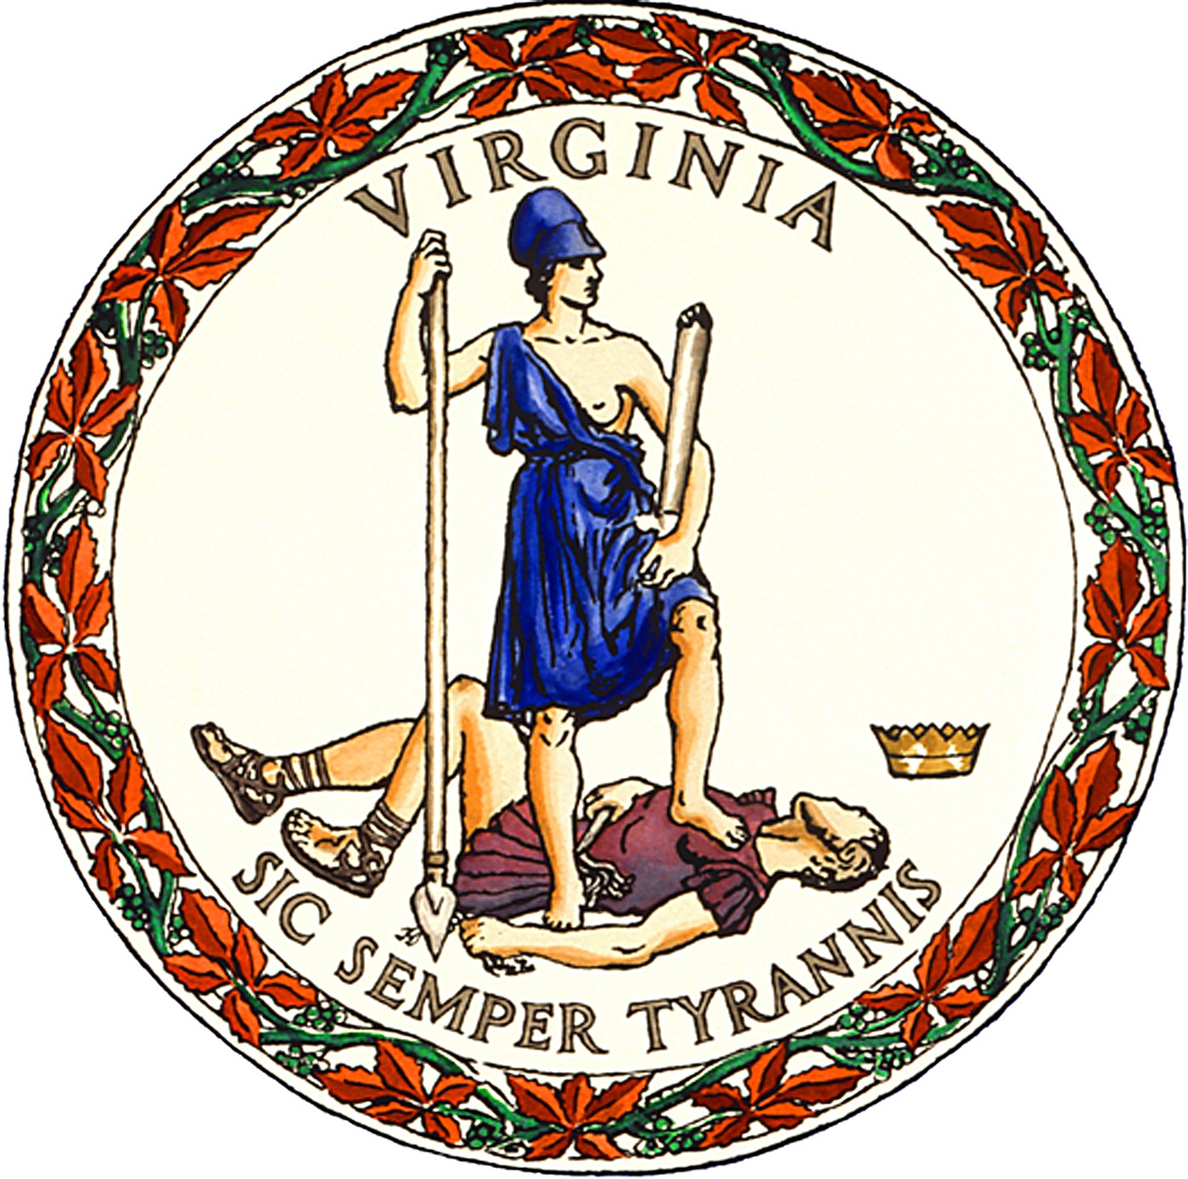

PUBLIC NOTICE
for the
June 18, 2024 Republican Party Primary
in
Bland County, Virginia

In-person, early voting for Bland County voters will be available at the location, date, and hours listed below beginning Friday, May 3rd, and ending Saturday, June 15th.

- 20 Fairground Street, Bland, VA 24315, Monday-Friday, 8:00 AM-4:00 PM. This office will also be open on Saturday, June 8th, and Saturday, June 15th, from 9:00 AM-5:00 PM.

Ballot drop-boxes: a ballot drop-box will be available for voted ballots the same dates, times, and locations listed above for in-person, early voting as well as on Monday, June 17th, from 8:00 AM-4:00 PM. Drop-boxes will also be available at all regular polling places on Election Day, June 18th, from 6:00 AM until 7:00 PM.

STACY TIBBS GRADY
Director of Elections and General Registrar
Posted: April 24, 2024

Va. Code §§ 24.2-701.2(E), -707.1(C)

